Mr. Newsom
10th Grade U.S. History Syllabus

INSTRUCTIONAL GOALS
This course will examine the history of the United States immediately following Reconstruction to present day. Students are expected to understand and apply the significance of these events in our nation’s history to their lives.
- Students will have an understanding of how his or her world is affected by outside influences.
- Students will learn the: problems, achievements, failures, strengths, weaknesses, ideals, and peoples in our nation’s history.
- Students will also master these essential skills:
-Analyzing Documents -Map Skills -Graph and Chart Analysis -Cause and Effect
-Point of View -Continuity and Change Over Time -Compare and Contrast

- We will read and write on a daily basis.
  - What will we read? United States History-Reconstruction to the Present (textbook/online), news articles (hard copy/online), and primary documents.
  - What will we write? First person interpretations, about our thoughts, and about things we read/discuss.

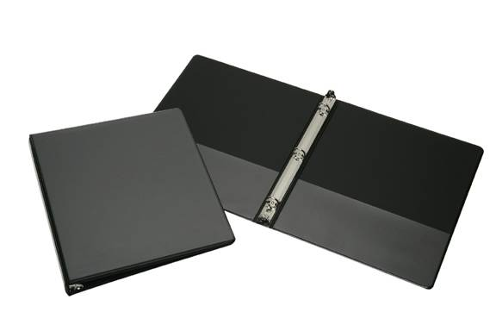
**REQUIRED MATERIALS**

To successfully complete this course, students will need the following materials.
ALL STUDENTS
- 1 inch binder (You will leave this in my room)
- 5 Tab dividers labeled: Bell Work, Notes, Assignments, Tests/Quiz, Journal
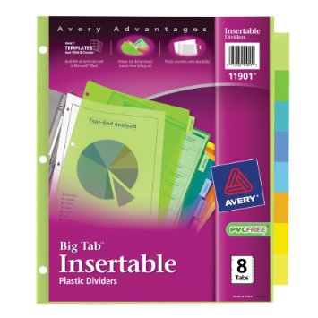
- Notebook Paper inside the binder
- Pencils, Red Pens, and a Highlighter
**SEPARATE HOURLY REQUIREMENTS**
- 4th Hour -1 pack of Red pens
- 5th Hour- 1 pack of Red pens
- 6th Hour-1 box of tissues

POLICIES AND PROCEDURES
CLASS RULES
- Students will respect each other and Mr. Newsom.
- You CANNOT be on your cellphone or have headphones on unless I give you permission.
- Be in your assigned seat and started on the bell work before the bell rings.
- Students will put their book on the back counter before they leave.
- Follow directions the first time they are given.
- Work to the best of your abilities which includes asking for help when you need it.
- Follow all the rules in the student handbook

TARDY POLICY
Students will be considered tardy if they are not in the classroom before the bell rings and truant if they are more than 10 minutes late.
1st Tardy- Written warning & call parent
2nd Tardy- Lunch Detention & call parent
3rd Tardy- 2 Lunch Detentions & call parent
4th Tardy- Referral to the office

RESTROOM AND HALL PASS POLICY
- Go to the bathroom during your passing time!
- Students will not be allowed to leave class the first 10 minutes of class or the last 10 minutes of class.
- Students will have to have their ID to receive a pass to leave the classroom
- I will limit bathroom passes to emergencies only

ASSIGNMENTS AND TESTS
Presentation of material will be varied, but for the most part, will include: lecture using smart board presentation with notes, class discussion, class readings, short video clips, and review games played before most tests.
- Assignments- will include: Bell work, in class writing, current events, worksheets, and other various assignments.
- Tests- We will have a test every three to four chapters. The test could consist of: multiple choice, true/false, fill in the blank, matching, or essay.

1
GRADING POLICY
There are 4 categories for grades and they are weighted as shown below.
Bell Work 5%
Assignments 30%
Notes 30%
Test/Quiz 35%
*Semester Exams (1st and 2nd) 10%

Semester grades are calculated as follows:
- Each semester test is weighted as 10% of the semester grade.
- The chapter tests and homework grades are 90% of the semester grade.
- Test grades are worth more points, because tests demonstrate the student’s command of the subject matter. It should be noted that it will be difficult to pass the course if homework is neglected, both areas are important.
Schools Grading Scale
A 90% or above
B 89% to 80%
C 79% to 70%
D 69% to 60%
F 59% and below
MAKE UP WORK POLICY
- If it is related to an excused absence then the school policy will be used. A student is given one day to make up the assignment for each day the student was absent. If it is not turned in by then it will be a zero.
- If a student was truant they will not receive credit for any assignment they missed while they were gone, until they go to Homework Rescue, before or after school, and get the assignment stamped.

ADDITIONAL INFORMATION
- I will be available before school and after school for extra help if needed, but please let me know ahead of time so I can make necessary arrangements.

CONTACT INFORMATION
If you have any questions my planning period is 8:20-9:20, which is the best time to reach me by phone. Otherwise, send me an e-mail any time and I will get back with you as soon as possible.
Zach Newsom
(918) 357-7333
newsom.zachary@unionps.org
Class Website
This is the web address to my U.S. History class website. You will be able to find this syllabus, lecture notes (PowerPoint), and other daily assignments you may have missed due to an absence.
newsomhistory.weebly.com

Text Reminders (Remind)
If you would like to receive important reminders for U.S. History via text message then students and parents can send a text message to this number (918) 921-8860 with @newsom2710 as the message. You will then be asked to respond with your name, please just use your first and last name. You will then receive any important messages I send out about the class. (This is not my personal cell number, it is a one way message number given by Remind)
Twitter
You can also follow my U.S. History Class on Twitter @MrNewsUSHistory for information and reminders.

I reserve the right to alter the syllabus (i.e. course requirements) for this class should it be necessary. Any changes will be fully explained to students.

*Please sign and keep in your History notebook Newsom U.S. History Syllabus 2017-2018

Student Signature: ____________________________________________________________ Date: ______
Please Sign and Print

Parent Signature: ____________________________________________________________ Date: ______
Please Sign and Print

